Level Design Document

Assignment 3

By: Marco Chu (1645504)

Level 1: Fwoosh City

Version 0.3

**2. Level Information:**

The morning was bright and the wind soft, is what Callum would have said if he wasn’t distracted by the bickering of the Hat. After countless weeks climbing up Mount Everclean, Callum had finally done it. He was finally on the road to Fwoosh City, only a couple of jumps across some magical floating rocks was in the way between him and reaching the Washing Machine King, who is supposedly famous for being able to clean out anything, thus, removing his newly acquired wretched head gear should be a piece of cake. Yet, in the back of Callum’s mind, he felt that his journey was far from over, however, like most problems Callum faces he had simply left that thought to dwell in the depths of his subconsciousness, cause there was no way that was true…

**3. Level Location:**

The level will take place on the mountain path to Fwoosh City, a path, made by magical bricks, floating on the same altitude as the mountain peaks. This path has lead a handful of people to the glory of his holiness, as well as their demise. However, although dangerous, Callum is determined to take off this ridiculously looking, dumb sounding, itchy fabric hat. This is his final destination, the end of his journey, this is the place of the mystical Washing Machine King that is capable of removing anything from a person, whether it be a stupid Hat or an overbearing regret.

**4. Difficulty and Game Design Philosophy:**

* The level begins at a slow pace where the player only needs to jump from platform to platform. This is so that the player can get used to how far the character can jump normally.
* The level will slowly ramp up its difficulty by first introducing the walk enemy near the end of the first stage to act as a beat. The player will not have their weapon yet, thus, it emphasises the importance of player movement and where they land.
* However, if the player falls down in the first gap, they are introduced to a secret stage in the game, where they can obtain the shooting function. The player will then eventually find themselves at the end of the first stage. One of the fun elements that challenge the player is when they find a secret as these paths will either be difficult to cross or difficult to find
* Ultimately this level is designed to challenge the players ability to manoeuvre from platform to platform, whilst also dodging enemies along the way. However, there is also a challenge on the players patience as the game isn’t designed to simply kill the player but rather have the player reclimb the level if they were to fail to make a jump. Somewhat applying a similar idea to 2017’s ‘Getting Over It’

**5. Level Metrics:**

In this level, it emphasises on teaching the player the necessary skills for playing the game, by showing them the core mechanics that will be reused in different scenarios later in levels.

* The player will be taught each control through dialogue boxes throughout the level. After these dialogue boxes they will be put in a scenario where they will adapt this new mechanic in their game play. For instance, at the beginning the player will be taught how to jump, then they will be faced with gaps in the ground placed in a variety of distances between each other . The player will later be challenged in their skill in using the mechanic as the level progressively gets harder. Thus, later in the level players will have to jump and dodge enemies or jump on moving platforms.
* The level will adjust to players that are skilled and unskilled at this game as the level is set out to teach new players the mechanics of the game, but still challenge them. However, players who have beaten the level before can choose to look for these secrets in the level, which is a challenge in itself.
* In this level the player is only able to use 3 mechanics: Jumping, Attacking and Running. However, the emphasis on this level is rather put on the Running and Jumping, whilst shooting in a sense is optional as the player can choose to obtain the mechanic.
* Falling off platforms will lead to players losing progress as they will fall to a lower stage in the level. This will be indicated through Callum’s inner speech where he could say” It would surely take a lot of time to get back up if I fall”.
* Essentially the player can either fail through losing all their health or stop playing all together because they almost reached the end but missed a jump and fell to the beginning of the game.
* The player will ultimately succeed when they find a balance between speed and control over the character as they can slice and dodge their way through the level.

**6. Overview:**

* The player will be introduced to a path leading to Fwoosh City, a mountain platform area where the player will have to make a series of jumps across a number of platforms. These jumps are not difficult, thus the player should easily grasp the mechanic and pace through it at a steady pace. However, if the player misses the platform and fall past the bottom of the level they will lose a life and start from the beginning of the game. However, if the player misses the first jump they end up in a pit with a button, which opens the path to the secret stage of the level.
* This is also where the game will introduce the two enemies, the Pants enemy, who runs back and forth, making it more difficult for the player to manage their jumps as they will have to reach the platform without being hit by the enemy, as being hit by an enemy will lose the player a life.
* After a making it past a couple of platforms and opening the door. The player will be introduced to a spiral of moving platforms they will have to climb up, which will have the Pants enemy as well as the Shirt enemy, which will shoot projectiles at the player. This is usually where most mistakes will begin to occur.
* After reaching the top the player will have to manoeuvre between moving platforms, which tests the player’s ability with the first mechanic they have learnt for the game as this is much more difficult to manage.
* Once the player passes all the platforms, the player will be introduced to the jump enemy as well as the second secret in the game, where the player will have to push a block off the edge to open a door which leads to the player obtaining a power up which allows them to shoot.
* After clearing a couple more enemies the player will need to make a jump between two moving platforms. If they miss they can ultimately land back at the beginning of the level
* The player will then land on the edge of the ‘Mountain’ where there will be more combinations of enemies. If the player has acquired the power up they can blast straight through them.
* The player will reach a narrow straight path where there is a mob of enemies waiting for them. The player will have to manage their jumps as if they jump too high they will collide with the ceiling and end up falling quicker than expected.
* At the end the player will climb up a flight of stairs, where they will end the level

**7. Theme:**

Game-Play Elements:

* The overarching theme of the game is clothing, magic and height. This theme is inspired by a mix between 2017’s frustrating game ‘Getting Over It’ as the level is set out to not kill the player but have them fail through falling to the beginning over and over again. The game is also inspired by MegaMan 2, as the player can choose which boss they want to fight, however in those levels if the player lost all their health, they would have to start from the beginning, as there are no checkpoints. These two factors, aside from the platforms and enemies are the main challenges and frustrations for the player throughout the game. Furthermore, by including magic it allows the believability of the ridiculous theme that the player is set in through the weapons they able to obtain as well as the enemies that the player will face.
* Whilst playing through the level, the player will be introduced to three key enemies, a walk enemy, jump enemy and shoot enemy. These three enemies will be represented through a pair of pants, boot and shirt looking creatures respectively. The idea behind using these types of clothing is to associate the common usage they have in the real world, for instance pants are usually worn to be walked around in. Therefore, the player can relate and associate these connotations beforehand.
* The game is based around a mountain where the protagonist Callum is told that a magical Washing Machine King can remove wash away anything a person wishes to be off them. However, he lives on Fwoosh City, the Royal Capital of the nation which is based on the peak of Mount Everclean. Therefore, height and risky platforms are a huge factor when climbing a mountain, especially since the level is set near the peak.
* The platforms used in the level will be rocks to further emphasise to the player that they are scaling a mountain. However, these platforms are also contrasted with white and gold platforms to replicate the connotation of the “Yellow brick road” and indicate to the player that they are also on a path to a Royal City, where the player has to follow the platforms to find the city.

Narrative & Thematic Elements:

* The platforms used in the level are rigid to further project that the player is scaling a mountain. However, these platforms are also White and Gold to represent how the character is traveling to the royal capital.
* There is a distinction between the moving platforms and stationary ones, as the moving platforms are indicated with red crystals to add to the magic feel, whilst the stationary ones are bedrock looking tiles or the common blue crystal tiles.
* The sky is a hue of green blue and orange to depict the morning sky. This is used to draw comparisons between the beginning of the day and the beginning of the game.
* The game will also have various dialogue showing the different uses of each button at different stages of the game.

**8. Level Beats:**

* The first beat the player faces in the level is where they are challenged to make precise jumps. This demonstrates to the player the core theme of the game being one of jumping across platforms. It also demonstrates that the player will have to adapt to the mechanic to complete the level as they cannot get to the next stage if they do not make all the jumps. These platforms will also be a subconscious indication to the player on how far and how high the player can jump.
* As the player climbs further up the mountain path, they will be challenged by walking enemy at the end of Stage 1. This further develops the player’s ability to jump precisely.
* In the level, if the player had found the first secret, they would have to jump across a number of platforms that are fairly small. The player is forced to use this path as there is not a way to get back to the main path until they either clear the secret path or fall and restart.
* The player will cross the first stage of the game and enter an are where the player will have to climb up some stationary and moving platforms, whilst dodging some Walking and Shooting enemies.
* Reaching the other side of the door the player will be faced with more moving platforms with shooting and jumping enemies on them. This further challenges the players ability to use the core mechanic of jumping whilst dodging projectiles and enemies.
* The player will then reach a tunnel in the mountain which creates a narrow path through the mountain. In the narrow path there will be a mob of enemies. Depending on whether the player obtained the powerup, they will have to either dodge or shoot their way through the tunnel.
* At the end the player will reach a set of stairs, however, if they manage to fall off these steps, they will return back to the second stage of the level, adding to the frustration of the game.

**9.Pacing and Progression:**

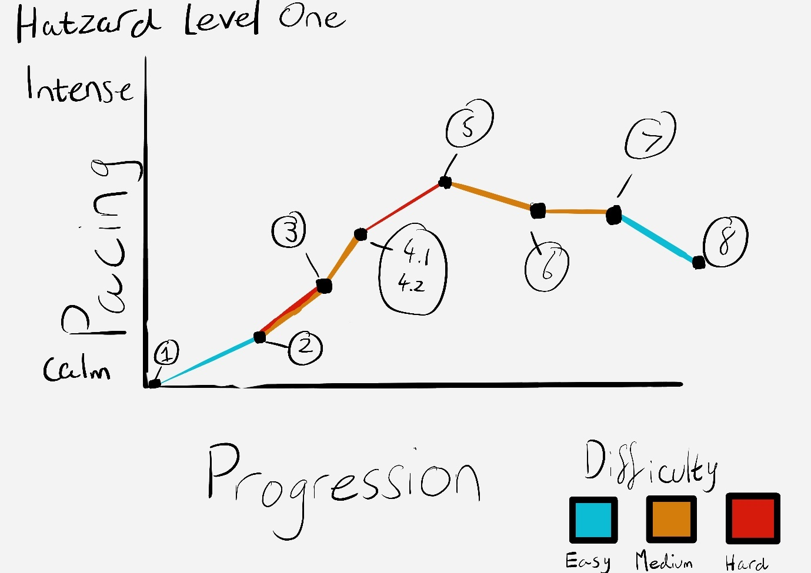

|  |  |
| --- | --- |
| **Beat 1** | Player reaches the cliff, where there are floating platforms for the player to begin jumping on. |
| **Beat2** | If the player falls they will have to pass through the secret path, however at the end they will receive a powerup that enables the player to shoot |
| **Beat 3** | Climbs up moving and stationary platforms, whilst dodging Walking and Shooting enemies |
| **Beat 4.1** | Reach the top where the player will manoeuvre between moving platforms |
| **Beat 4.2** | Find the second secret, that will give the player the shoot powerup if they didn’t have it already |
| **Beat 5** | Player will once again manoeuvre between moving platforms, however if the player fails the jump they will ultimately end up at the beginning again |
| **Beat 6** | Player reaches a narrow path through the mountain. |
| **Beat 7** | Player will encounter a mob of enemies |
| **Beat 8** | Player reaches stairs, if they don’t make the jump they will go back to the second stage of the level |

**10. Actors:**

Callum:

* Callum is depicted as a timid, yet optimistic young boy whose immediate purpose is to take off an annoying Hat he had the misfortune of plonking on his head one day. Callum’s nature can be seen through his facial expression as he always seems like he is crying but contrasted with his dialogue which is somewhat cheerful.
* Callum’s mechanics allow him to run, jump, attack . However, in most levels Callum’s attack function is sometimes optional
* Callum can interact with all interactable, this includes:

All enemies, where he can damage and kill the enemy, whilst also able to take damage from them

The pick-up for his powerup, where he receives his weapon.

All the platforms he needs to jump across and to.

Panels to open doors.

Enemies:

* All three enemies can interact with Callum as they can be damaged by him or damage him.
* Enemies will also react to the terrain around them and will act differently when approached by the player:

Shoot Enemy- Will stay stationary, open its mouth and lift its arm, indicating it is about to shoot.

Jump Enemy- Will begin to jump faster towards the player with its eyebrows waving.

Walk Enemy- Will begin to walk faster towards the player.

**11. Technical Limitations:**

By building the game through the 2D Game Kit on Unity, multiple suspecting issues may arise in the game.

* The time function is one of the core mechanics that challenges the player as it brings in another level of difficulty into the game. However, the game kit may not have a time function that is able to count down and be used to trigger events. Therefore, an alternative method may need to be used to project this function as it sets the pace of the level.
* Removing the functions of a player after a certain amount of time may also be another limitation as it may require changing the scripts to work with the aforementioned time function. However, even if removing functions is possible, more issues may arise in terms of building and balancing, as the player should theoretically be able to run through the level even if all three mechanics are taken away, preventing a player to get stuck at a point in the level.
* Removing the wind mechanic will result in the game ultimately losing all three core mechanics. This effect of the player being pushed can somewhat be obtained through Unity’s in-built ‘Windzones’, however, to the designers knowledge this function is only implemented for aesthetic purposes and not to directly push a player. However, an alternative can be applied where instead of using wind.
* Ultimately, due to the kit being unable to support the mechanics mentioned above, they will be removed. However, although these two core conflicts will be removed from the core game, it still needs to retain an element of challenge towards the player. Thus, the game will change from a race against the time to a more dodge orientated game similar to the Super Mario series or MegaMan 2. Where weapons are given to skilled players that are willing to explore the map rather than race towards the end, giving an almost “Easter Egg” feel towards the game. This will, in a sense, bring back an element of reward to the player.

**12. Concept Art:**

Original Level Art:

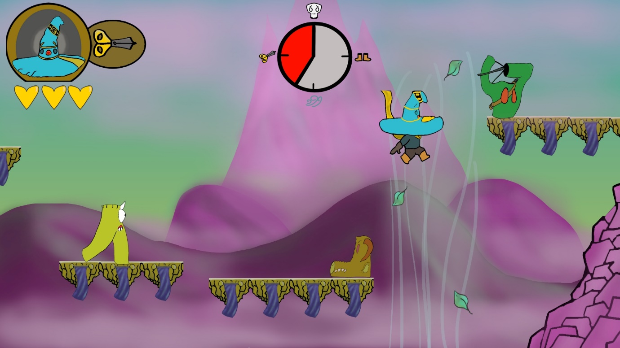

Level 1- Stage 3 1.0

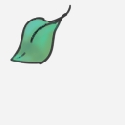

Game Prop (Leaf) 1.0



Game Prop (Heart) 1.0

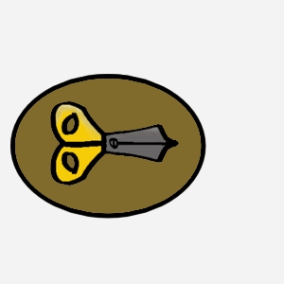

Game Prop (Scissor Icon) 1.0

Actor Art:

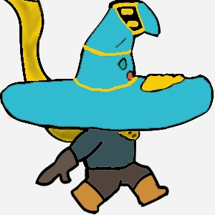

Callum (Side) 1.0

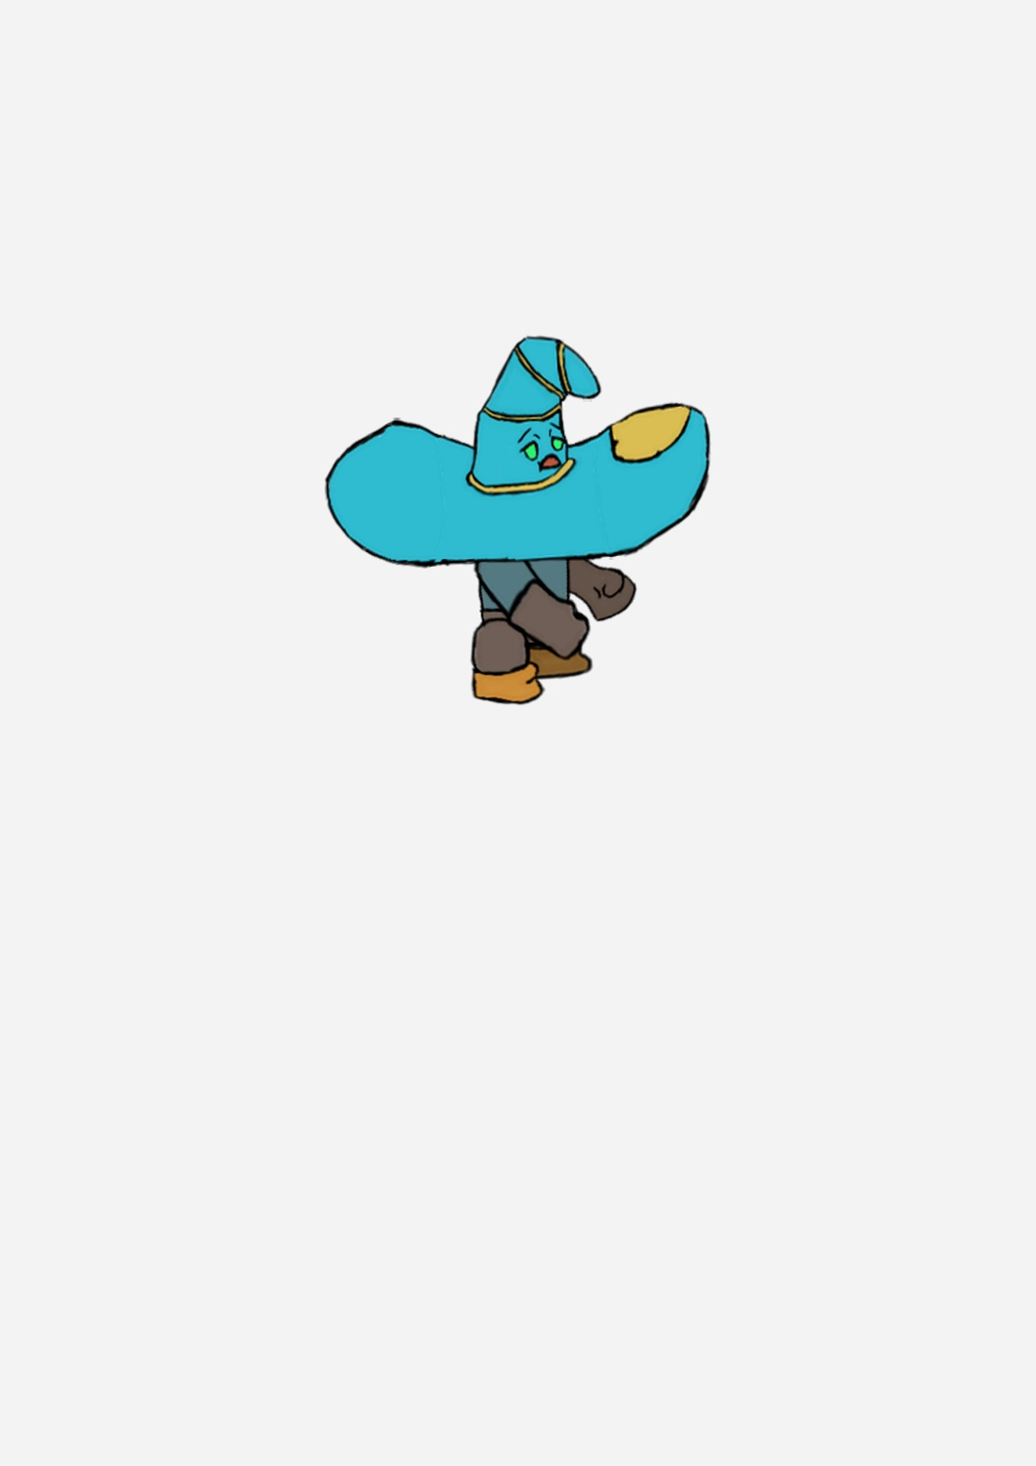

Callum (Side) 1.1

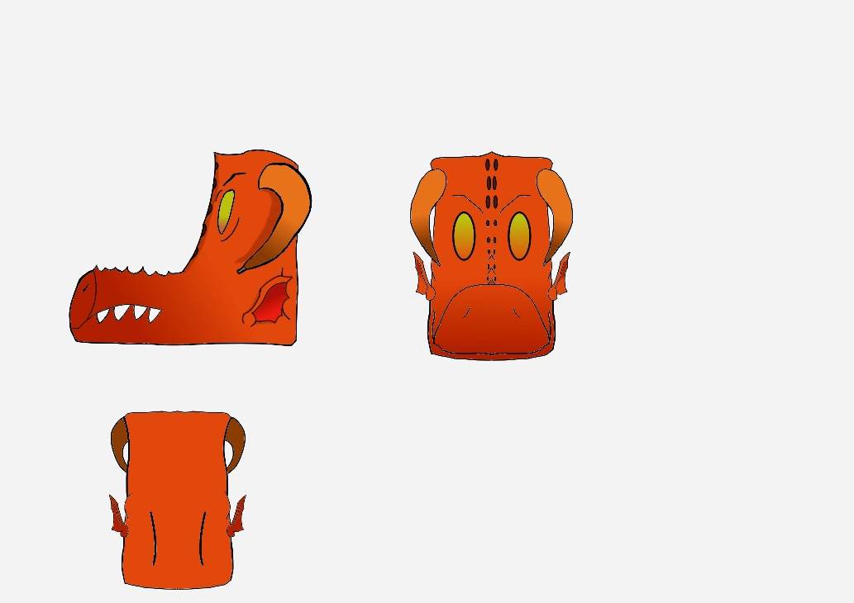

Jump Enemy (Boots) 1.0

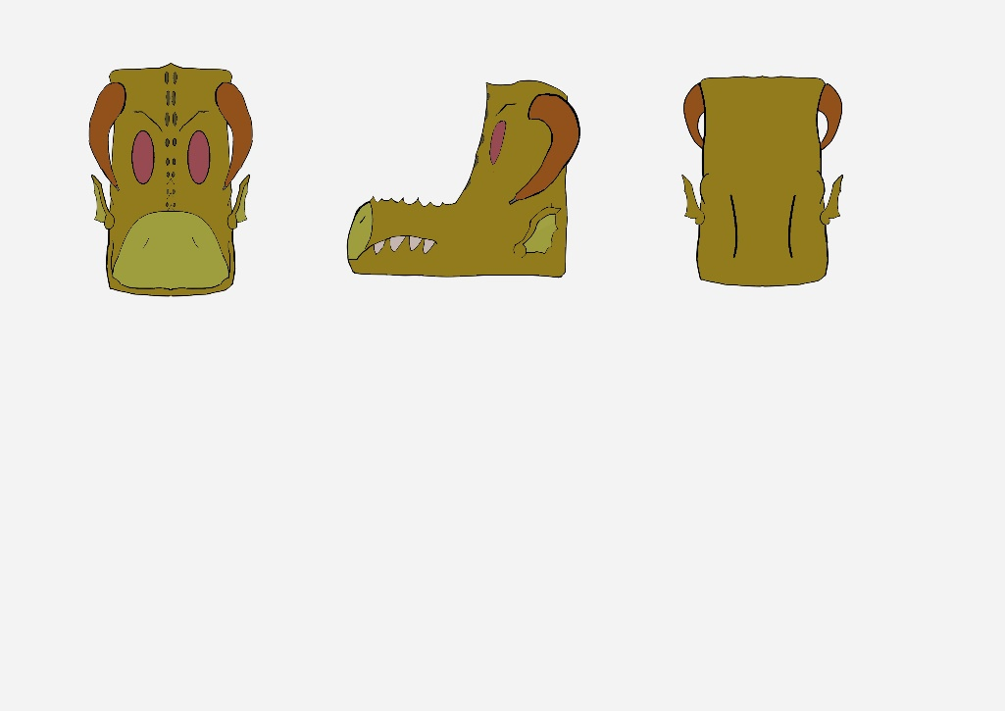

Jump Enemy (Boots) 1.1

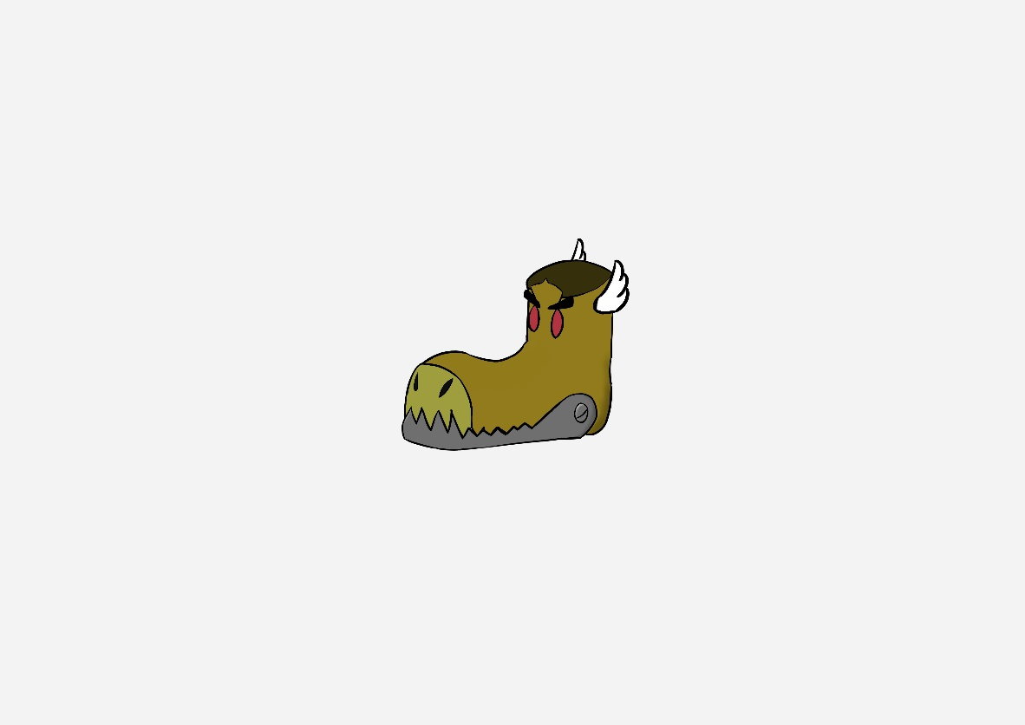

Jump Enemy (Boots) 1.2

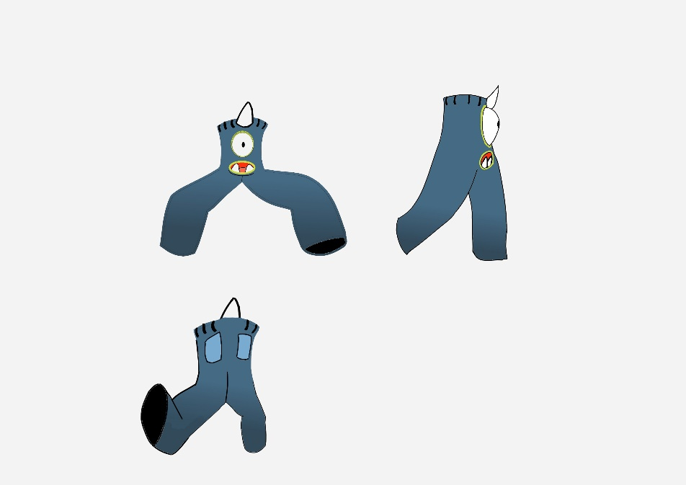

Walk Enemy (Pants) 1.0

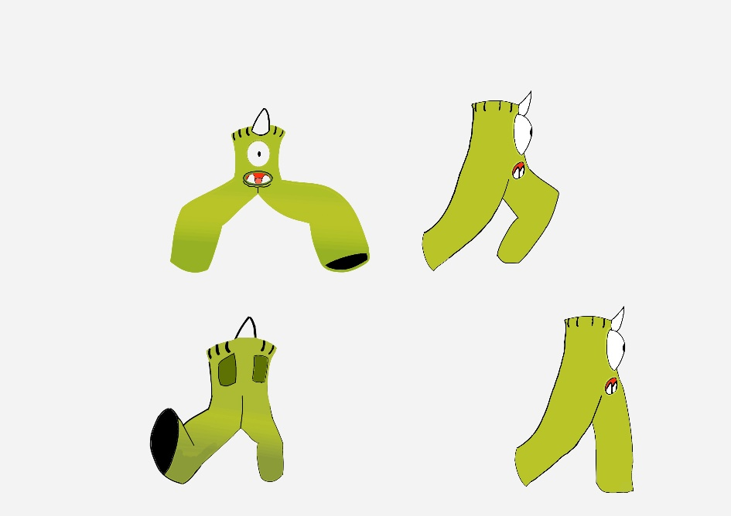

Walk Enemy (Pants) 1.1

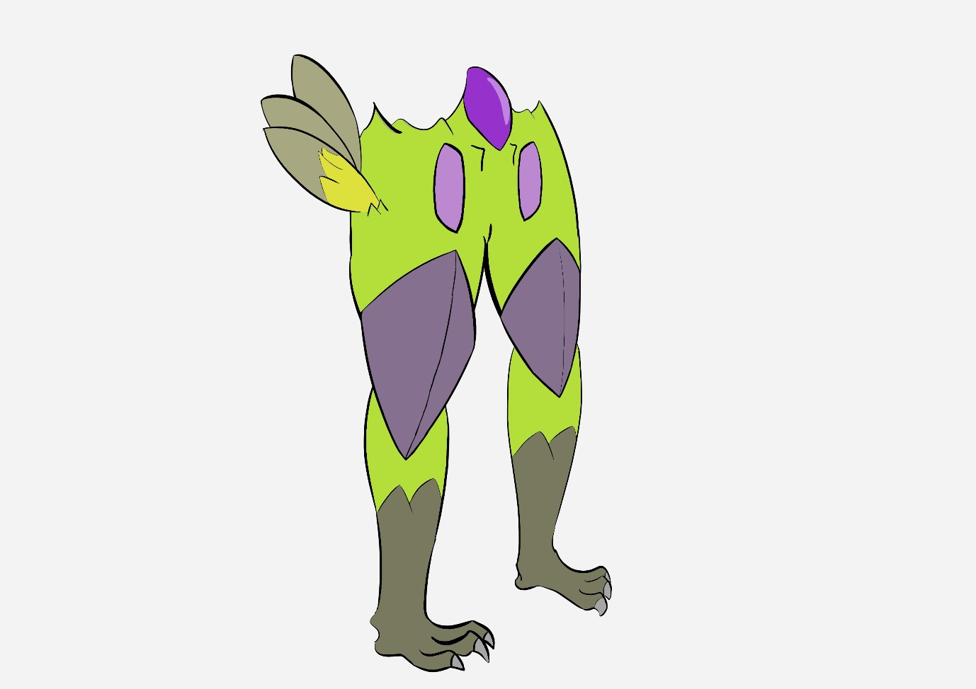

Walk Enemy (Pants) 1.2

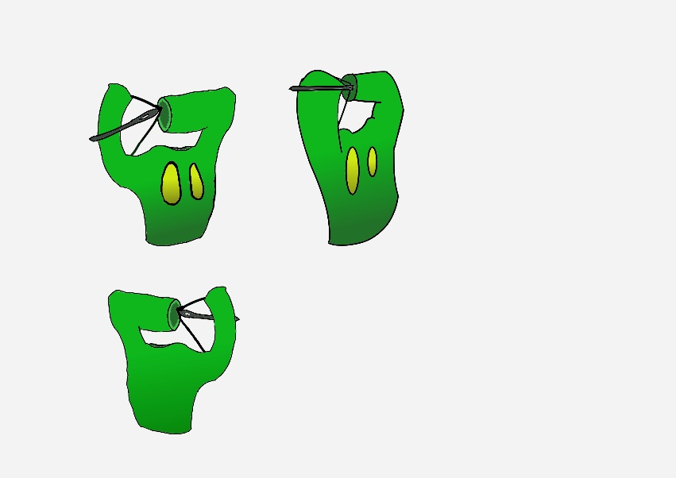

Shoot Enemy (Shirt) 1.0

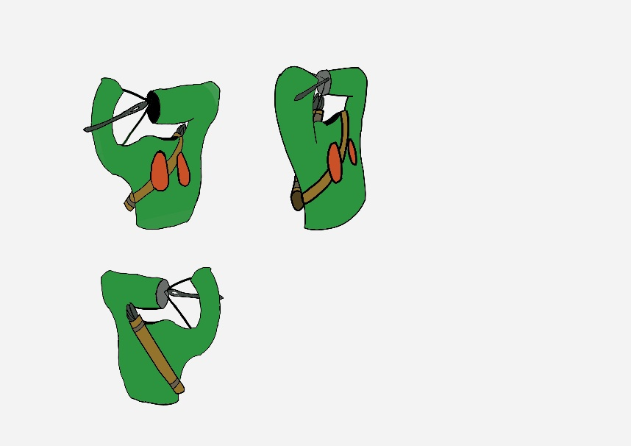

Shoot Enemy (Shirt) 1.1

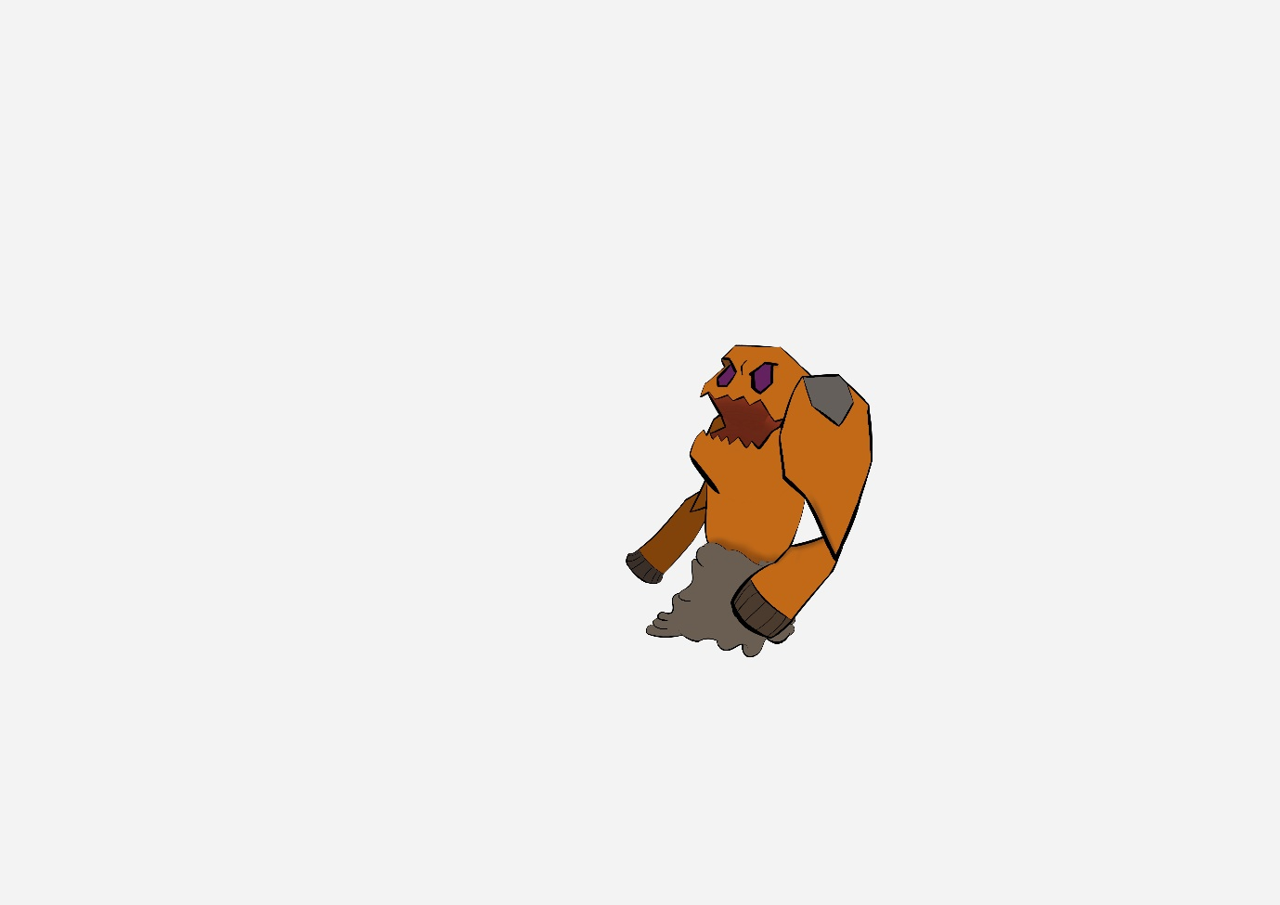

Shoot Enemy(Shirt) 1.2

**12.Level Diagrams**

